Nagar Yuwak Shikshan Sanstha’s


Yeshwantrao Chavan College of
Engineering
(An Autonomous Institution affiliated to
Rashtrasant Tukadoji Maharaj Nagpur
University) Hingna Road, Wanadongri, Nagpur - 441 110 NAAC A++
Ph.: 07104-237919, 234623, 329249, 329250 Fax: 07104-232376, Website: www.ycce.edu

Department of Computer Technology
Vision Statement of the Department.
To be a preferred hub for nurturing computer engineering aspirants through innovative, ethical, value-based technical education, impactful research, and industry collaboration, to become successful professionals contributing for the betterment of society. Mission Statement of the Department.
To nurture computer engineering professionals by offering Dynamic learning environment that encourages problem-solving using emerging technology, National Education Policy aligned evidence-based technical education, fostering ,innovation, research, and industry–institute collaboration & Holistic, ethical and sustainable development for lifelong success.

Session 2026-2027
Vision:Dream of where you want. | Mission: Means to achieve Vision

Program Educational Objectives of the program (PEO): (broad statements that describe the professional and career accomplishments)
PEO1 | Preparation | P: Preparation | Pep-CL abbreviation pronounce as
PEO2 | Core Competence | E: Environment  (Learning Environment) | Pep-si-lL easy to recall
PEO3 | Breadth | P: Professionalism | Pep-si-lL easy to recall
PEO4 | Professionalism | C: Core Competence | Pep-si-lL easy to recall
PEO5 | Learning | L: Breadth (Learning | Pep-si-lL easy to recall
 | Environment | in diverse areas)

Program Outcomes (PO): (statements that describe what a student should be able to do and know by the end of a program)
Keywords of POs:
Engineering knowledge,Problem analysis, Design/development of solutions,Conduct Investigations of Complex Problems, Engineering Tool Usage, The Engineer and The World,Ethics, Individual and
Collaborative Team work,Communication, Project Management and Finance, Life-Long Learning

PSO Keywords: Cutting edge technologies, Research

“I am an engineer, and I know how to apply engineering knowledge to investigate, analyse and design solutions to complex problems using tools for entire world following all ethics in a collaborative way with proper management skills throughout my life.” to contribute to the development of cutting-edge technologies and Research.

Integrity: I will adhere to the Laboratory Code of Conduct and ethics in its entirety.

Name and Signature of Student and Date
(Signature and Date in Handwritten)
Nagar Yuwak Shikshan Sanstha’s
Yeshwantrao Chavan College of Engineering
(An Autonomous Institution affiliated to Rashtrasant Tukadoji Maharaj Nagpur
University) Hingna Road, Wanadongri, Nagpur - 441 110 NAAC A++
Ph.: 07104-237919, 234623, 329249, 329250 Fax: 07104-232376, Website: www.ycce.edu

Department of Computer Technology
Vision Statement of the Department.
To be a preferred hub for nurturing computer engineering aspirants through innovative, ethical, value-based technical education, impactful research, and industry collaboration, to become successful professionals contributing for the betterment of society. Mission Statement of the Department.
To nurture computer engineering professionals by offering Dynamic learning environment that encourages problem-solving using emerging technology, National Education Policy aligned evidence-based technical education, fostering ,innovation, research, and industry–institute collaboration & Holistic, ethical and sustainable development for lifelong success.
Session | 2026-27 (ODD) | Course Name | Lab: JAVA STACK
Semester | 5 | Course Code | 23CT1506
Roll No | 64 | Name of Student | Rushikesh Bhondekar

Practical  Number | 1
Course  Outcome  Aim  Problem  Definition  Theory  (100 words) | - Understand various internet technologies.  - Design the web pages using HTML and CSS.  - Implement the XML technology to store the data.  - Develop the interactive web pages using JavaScript.  Write a Java program to demonstrate classes, objects, constructors, and methods.  Write a Java program to create a Student class that stores the student's name and marks in three subjects. Use a constructor to initialize the student details and a method to calculate and display the average marks of the student. Create objects of the Student class and demonstrate the use of classes, objects, constructors, and methods.  Java is an object-oriented programming (OOP) language in which programs are designed using classes and objects. The main purpose of OOP is to organize data and functions together, making programs easier to understand, reuse, and maintain.  1. Class  A class is a blueprint or template for creating objects. It contains data members (variables) and methods (functions) that define the properties and behavior of an object.  Syntax:  class ClassName {  // data members  // methods  }  2. Object

Nagar Yuwak Shikshan Sanstha’s
Yeshwantrao Chavan College of
Engineering
(An Autonomous Institution affiliated to Rashtrasant Tukadoji Maharaj Nagpur
University) Hingna Road, Wanadongri, Nagpur - 441 110 NAAC A++
Ph.: 07104-237919, 234623, 329249, 329250 Fax: 07104-232376, Website: www.ycce.edu

Department of Computer Technology
Vision Statement of the Department.
To be a preferred hub for nurturing computer engineering aspirants through innovative, ethical, value-based technical education, impactful research, and industry collaboration, to become successful professionals contributing for the betterment of society. Mission Statement of the Department.
To nurture computer engineering professionals by offering Dynamic learning environment that encourages problem-solving using emerging technology, National Education Policy aligned evidence-based technical education, fostering ,innovation, research, and industry–institute collaboration & Holistic, ethical and sustainable development for lifelong success.
Procedu re and  Execution  (100  Words) | An object is an instance of a class. It is created using the new keyword and is used to access the variables and methods of the class. Student s1 = new Student();  3. Constructor  A constructor is a special member of a class that is automatically called when an object is created. It has the same name as the class and does not have a return type. Constructors are mainly used to initialize object data.  4. Method  A method is a block of code that performs a particular task. It improves code reusability and makes the program modular.  In this practical, a Student class is created with student details and marks. A constructor initializes these values, while a method calculates the average marks.  An object is created to access the constructor and method.  Thus, the practical demonstrates the basic concepts of class, object, constructor, and method in Java.  Step for Implementation:  - Start the program and create a Java class named Student.  - Declare data members such as student name and marks of three subjects. 3.  Create a constructor Student() to initialize the student's name and subject marks. 4. Create a method named calculateAverage() to calculate the average marks using: Average = (Marks1 + Marks2 + Marks3) / 3  5. Create another method display() to display the student details and calculated average. 6. Create an object of the Student class using the new keyword.  7. Pass the required values to the constructor while creating the object. 8. Call the methods using the object to calculate and display the average marks. 9.  Compile and run the Java program.  10. Observe the output showing the student's details, marks, and average marks.
Procedu re and  Execution  (100  Words) | Code:
 | 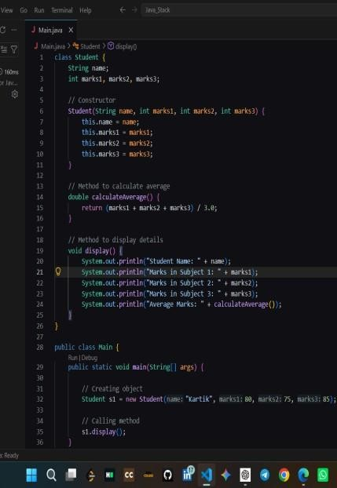

Nagar Yuwak Shikshan Sanstha’s
Yeshwantrao Chavan College of
Engineering
(An Autonomous Institution affiliated to
Rashtrasant Tukadoji Maharaj Nagpur
University) Hingna Road, Wanadongri, Nagpur - 441 110
NAAC A++
Ph.: 07104-237919, 234623, 329249, 329250 Fax: 07104-232376, Website: www.ycce.edu

Department of Computer Technology
Vision Statement of the Department.
To be a preferred hub for nurturing computer engineering aspirants through innovative, ethical, value-based technical education, impactful research, and industry collaboration, to become successful professionals contributing for the betterment of society. Mission Statement of the Department.
To nurture computer engineering professionals by offering Dynamic learning environment that encourages problem-solving using emerging technology, National Education Policy aligned evidence-based technical education, fostering ,innovation, research, and industry–institute collaboration & Holistic, ethical and sustainable development for lifelong success.
Output:

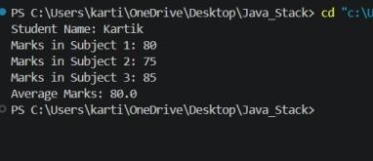
Output  Analysis  Link of student Github profile  where  lab assignm ent has been uploaded  Conclusion | The program successfully creates a Student class containing the student's name and marks in three subjects. The constructor initializes the student details when the object s1 is created. The calculateAverage() method calculates the average marks using the given formula. The display() method displays the student's details and average marks. For marks 80, 75, and 85, the calculated average is 80.0. Thus, the output verifies the proper working of the class, object, constructor, and methods.  https://github.com/rushikesh-bhondekar/Java-lab  Thus, the Java program successfully demonstrates the concepts of classes, objects, constructors, and methods. The program calculates and displays the average marks of a student, showing how OOP concepts can be used to organize and perform operations on student data.
Plag  Report (Similari ty index  <  12%) | 9%
Date | 08/07/2026

